# Learning Outcome

# After completing this module, the student should be Able to develop the real time scenarios based on Node JS applications.

To meet the learning outcome, a student has to complete the following activities

1. Create an Angular application which can validate the email accepted from user
2. Create an Angular application with form validation

# 

# Activity 1

## Aim: Create an Angular application which can validate the email accepted from user

**Learning outcome:** Able to develop the real time scenarios based on Node JS applications.

**Duration:** 3 Hour

**List of Hardware/Software requirements:**

1. Operating System – Windows 10/11 or Linux
2. Command Prompt/Power Shell
3. Internet Connectivity, Browser (Chrome or Edge)
4. Text Editor – Notepad / IDE – Visual Studio Code/Any IDE
5. NodeJS
6. Angular CLI

**Code/Program/Procedure (with comments):**

**Step 1:** **To verify the node, npm version, use the following command:**

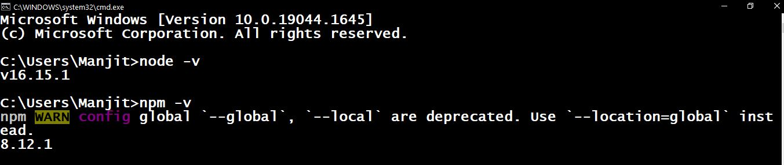

**Step 2: Installing Angular CLI**

The Angular command-line interface (CLI) tool allows you to initialize, develop, and manage your Angular applications. You can use the NPM package manager to install the Angular CLI.

**Access the Windows Command Prompt and enter the following command:**

First step, where we’ll have to install latest version of Angular CLI 14.0.1

**$ npm install -g @angular/cli**

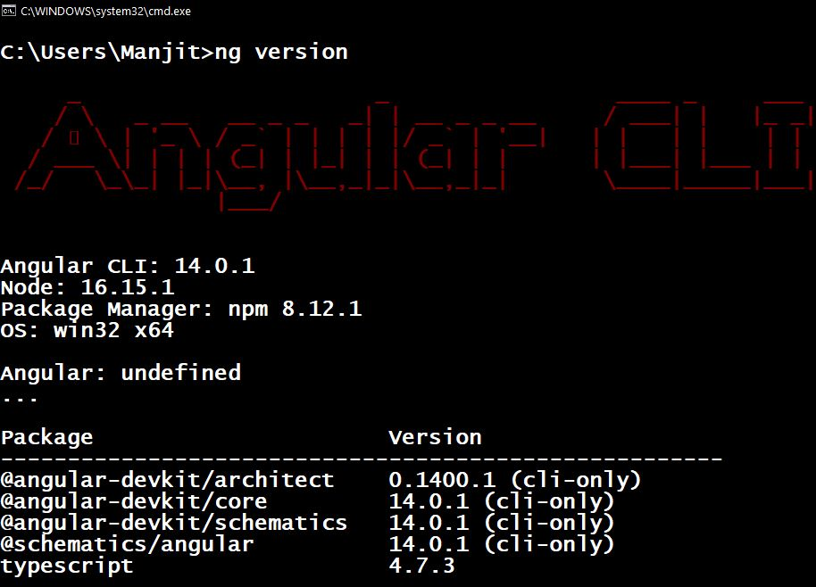

**Step 3: Creating your Angular 12 Project**

* In this second step, we will use Angular CLI to start our Angular Project
* Go to CMD or Terminal and use this command:

**ng new Validation**

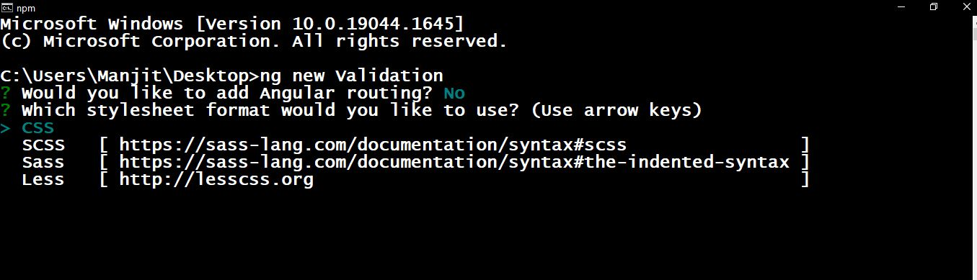

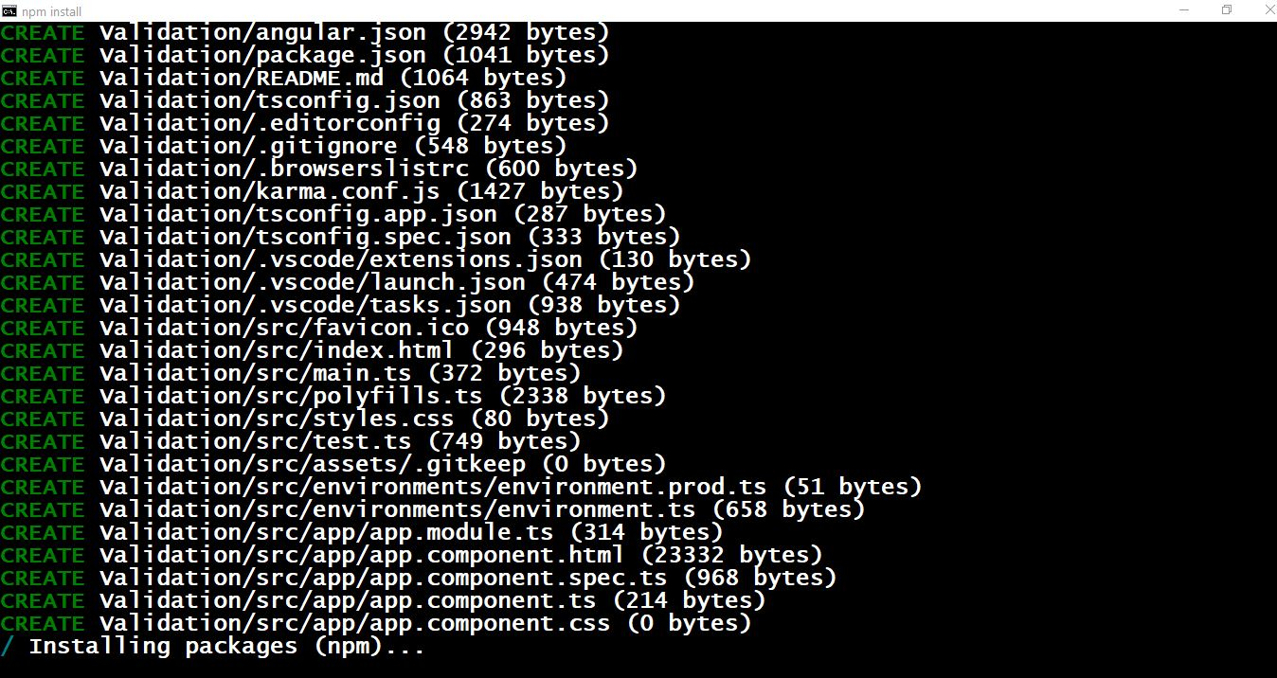

Once all packages have been added.

* This CLI will ask you “whether you would like to add Angular routing” Say Yes.
* It will ask “which stylesheet format you would like to use”. Choose CSS.
* Now your project is ready Angular CLI will generate required files and folders along with NPM packages and routing too.

**Step 4: Import FormsModule**

If you want to create form in angular app then you need to import FormsModule from @angular/forms library. so let's add following code to app.module.ts file.

**src/app/app.module.ts**

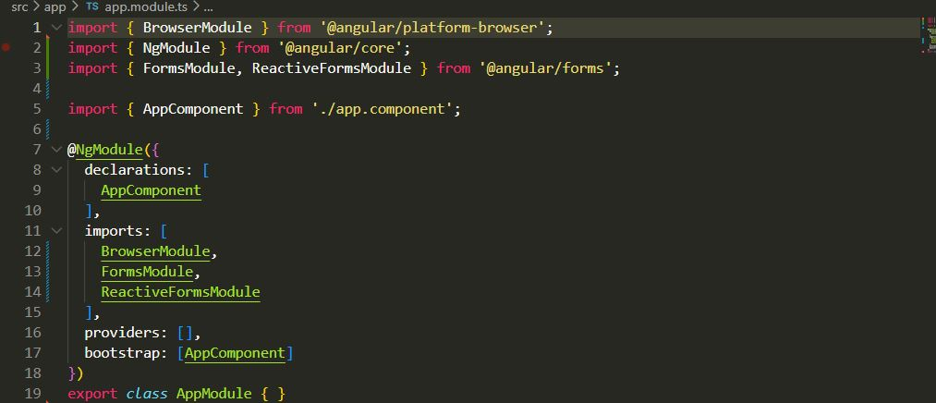

**Step 5: Form with ngModel**

In this step, we will write code of html form with ngModel. so, add following code to app.component.html file

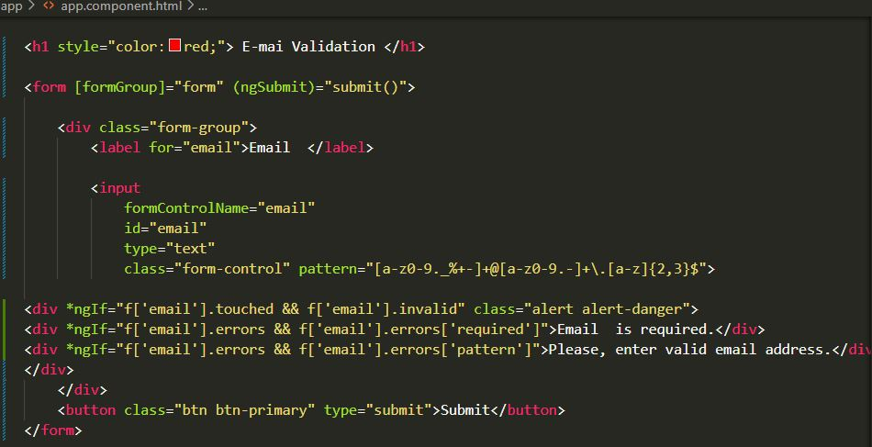

In this solution, you need to just install bootstrap on your angular 12 and import css file to style.css file. this is only for css importing. so, you can run command bellow:

**npm install bootstrap --save**

You need to import your bootstrap css on style.css file as like bellow:

**src/style.css**

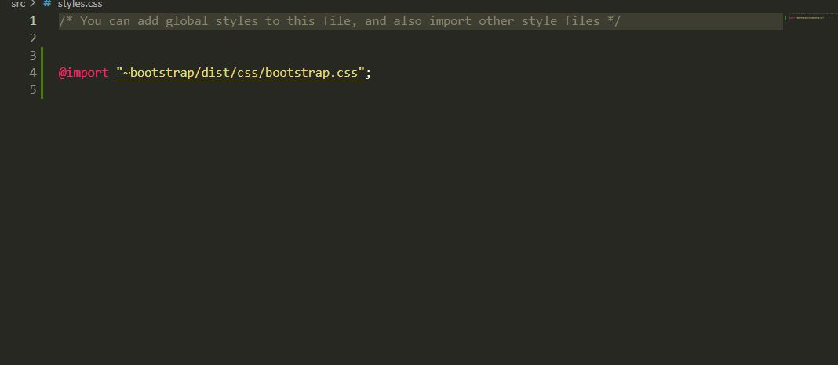

**Step 6: updated Ts File**

In ts file. we will write submit() and get all input fields values. so let's add following code to app.component.ts file.

**src/app/app.component.ts**

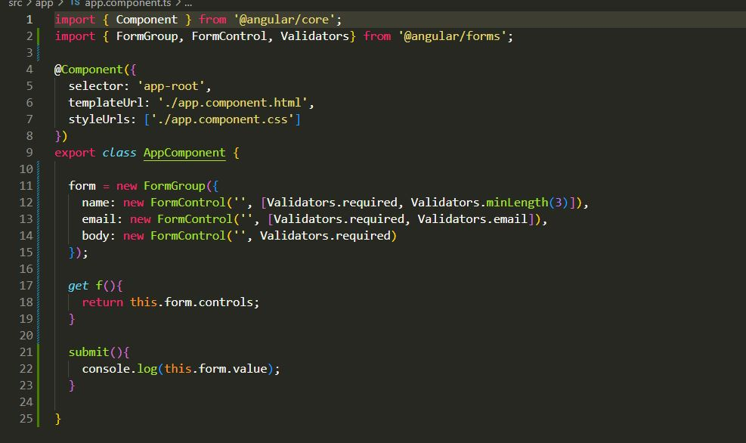

**Step 7:**  **Run your application**

The system proceeds to generate the environment for your Angular application.

Keep the Windows Command Prompt running. You can continue using the terminal, and the changes you make will be reflected in the application within your browser.

Use any browser to access your Angular local development server on localhost:4200:

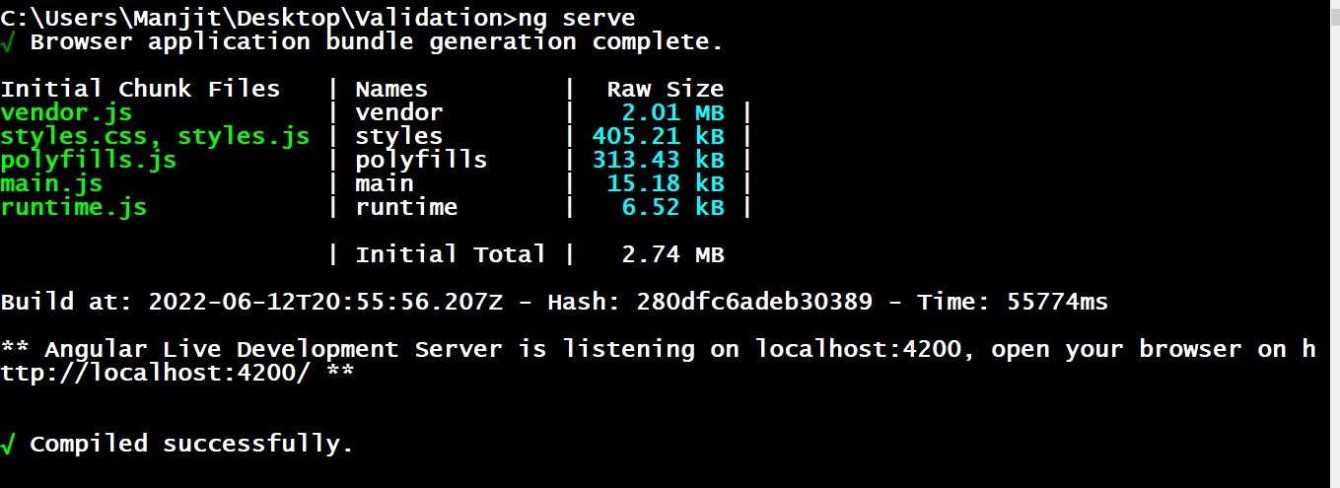

**Output/Results snippet:**

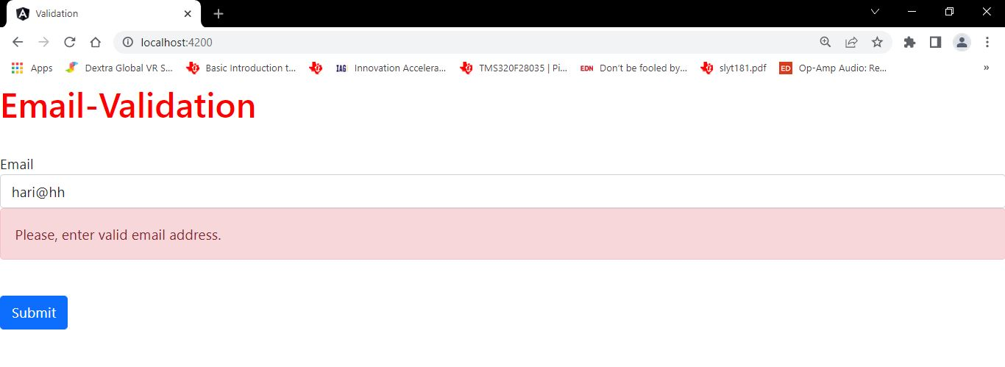

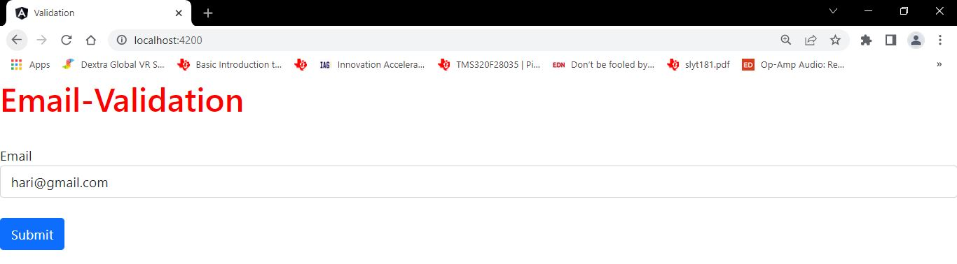

**Project Directory:**

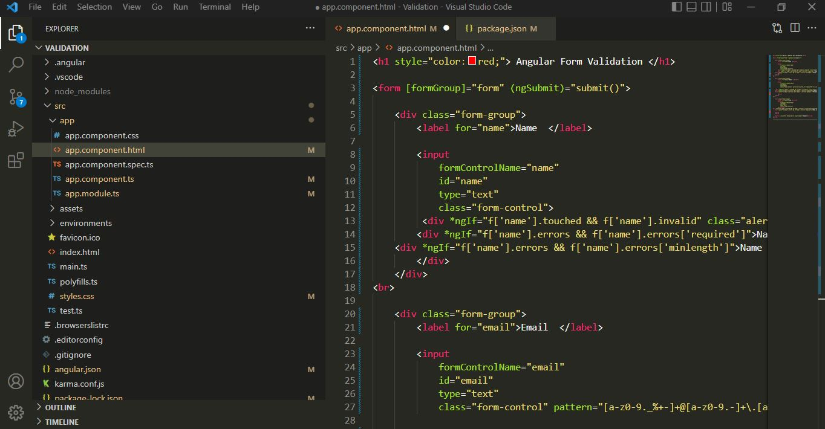

**References:**

* <https://www.itsolutionstuff.com/post/angular-12-reactive-forms-validation-exampleexample.html>

.

# 

# Activity 2

## Aim: Create an Angular application with form validation

## Learning outcome: Able to develop the real time scenarios based on Node JS applications.

**Duration:** 3 Hour

**List of Hardware/Software requirements:**

1. Operating System – Windows 10/11 or Linux
2. Command Prompt/Power Shell
3. Internet Connectivity, Browser (Chrome or Edge)
4. Text Editor – Notepad / IDE – Visual Studio Code/Any IDE
5. NodeJS
6. Angular CLI

**Code/Program/Procedure (with comments):**

**Step 1:** **To verify the node, npm version, use the following command:**



**Step 2: Installing Angular CLI**

The Angular command-line interface (CLI) tool allows you to initialize, develop, and manage your Angular applications. You can use the NPM package manager to install the Angular CLI.

**Access the Windows Command Prompt and enter the following command:**

First step, where we’ll have to install latest version of Angular CLI 14.0.1

**$ npm install -g @angular/cli**



**Step 3: Creating your Angular 12 Project**

* In this second step, we will use Angular CLI to start our Angular Project
* Go to CMD or Terminal and use this command:

**ng new Validation**





Once all packages have been added.

* This CLI will ask you “whether you would like to add Angular routing” Say Yes.
* It will ask “which stylesheet format you would like to use”. Choose CSS.
* Now your project is ready Angular CLI will generate required files and folders along with NPM packages and routing too.

**Step 4: Import FormsModule**

If you want to create form in angular app then you need to import FormsModule from @angular/forms library. so let's add following code to app.module.ts file.

**src/app/app.module.ts**



**Step 5: Form with ngModel**

In this step, we will write code of html form with ngModel. so, add following code to app.component.html file

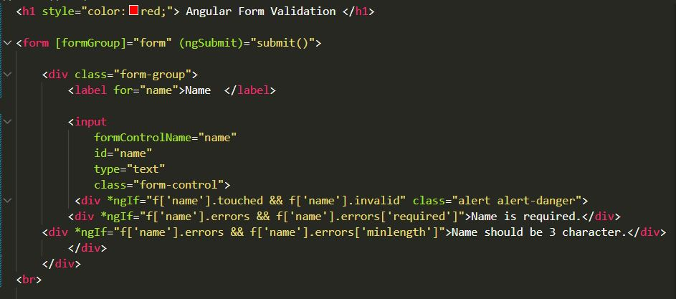

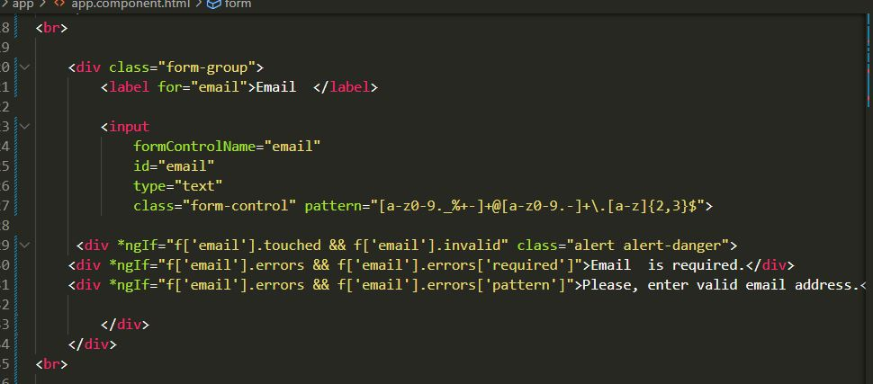

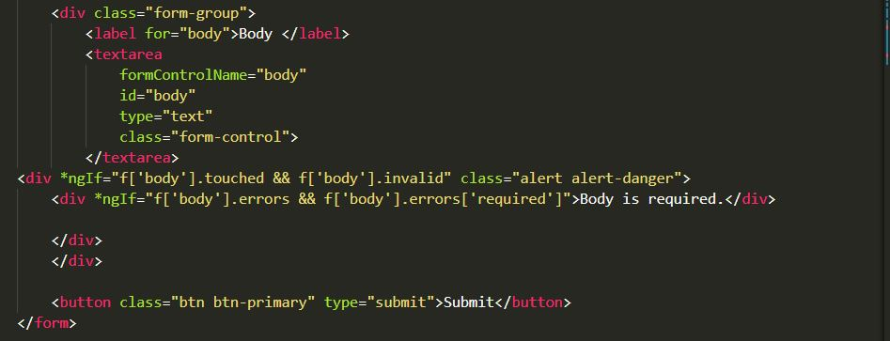

In this solution, you need to just install bootstrap on your angular 12 and import css file to style.css file. this is only for css importing. so, you can run command bellow:

**npm install bootstrap --save**

You need to import your bootstrap css on style.css file as like bellow:

**src/style.css**



**Step 6: updated Ts File**

In ts file. we will write submit() and get all input fields values. so let's add following code to app.component.ts file.

**src/app/app.component.ts**



**Step 7:**  **Run your application**

The system proceeds to generate the environment for your Angular application.

Keep the Windows Command Prompt running. You can continue using the terminal, and the changes you make will be reflected in the application within your browser.

Use any browser to access your Angular local development server on localhost:4200:



**Output/Results snippet:**

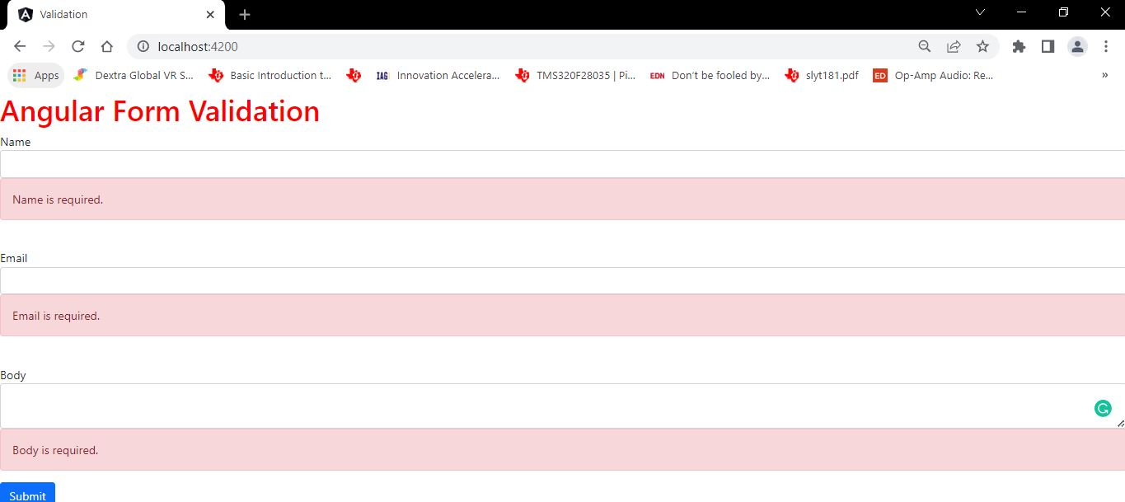

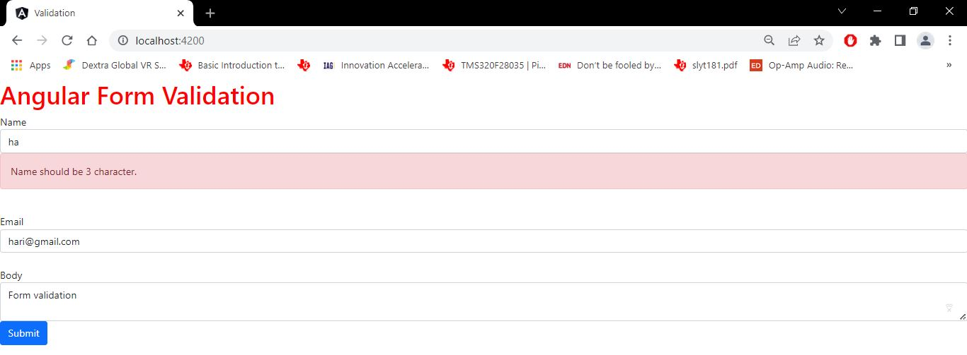

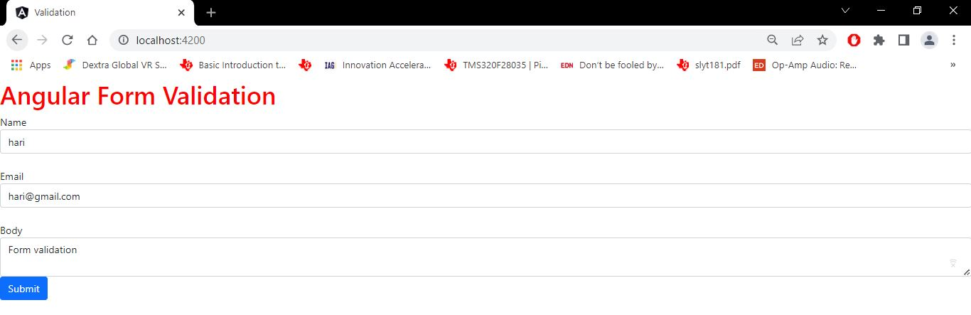

**Project Directory:**



**References:**

* <https://www.itsolutionstuff.com/post/angular-12-reactive-forms-validation-exampleexample.html>